NAME: K Yamini
REG NO: 192572181

Write a Python program to implement Decision Tree.
Aim:
To implement a Decision Tree algorithm to classify data based on given features.
Algorithm:
- Import required libraries.
- Prepare dataset (features and labels).
- Split data into training and testing sets.
- Create Decision Tree model.
- Train the model using training data.
- Predict output using test data.
- Compare predicted output with actual output.
- Display accuracy and results.
Python Code:
# Decision Tree
def decision_tree(weather, temp):
print("\nDecision Tree:\n")
print(" Weather")
print(" / \\")
print(" Sunny Rainy")
print(" / \\")
print(" Temp Temp")
print(" / \\ / \\")
print(" Cold Hot Cold Hot")
print(" | | | |")
print(" Don't Play Play Don't Play Play")
if weather == 0:
if temp == 1:
return "Play"
else:
return "Don't Play"
else:
if temp == 1:
return "Play"
else:
return "Don't Play"
# Input
weather = 0 # Sunny
temp = 1 # Hot
print("Input: Sunny, Hot")
result = decision_tree(weather, temp)
print("\nPrediction:", result)
Input:
Training Data:
Sunny Hot → Play
Sunny Cold → Don't Play
Rainy Hot → Play
Rainy Cold → Don't Play
Test Input:
Sunny Hot
Output :
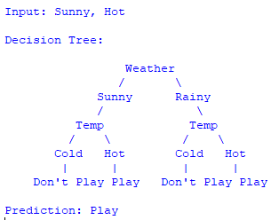
Result:
The Decision Tree algorithm is successfully implemented and used to classify input data based on given features.

